DFARS Compliance for Log360
Strengthen cybersecurity and meet DFARS compliance with Log360.
Region: USA | Type: Government/Public Sector, Industry Standard, Incident Management | Category: Compliance | Pricing: Free

Overview
The DFARS compliance extension in Log360 helps organizations meet the Defense Federal Acquisition Regulation Supplement (DFARS 252.204-7012), a mandatory DoD clause requiring defense contractors to safeguard Controlled Unclassified Information through NIST SP 800-171 controls by providing centralized log management, real-time threat detection, and automated audit reporting. The platform supports DFARS requirements for access control, audit accountability, cyber incident response, configuration management, system and communications protection, identity management, system integrity, and risk assessment.
For Access Control, Log360 monitors Windows and Unix logon events, failed authentication attempts, and Active Directory logon activity to verify authorized access and detect unauthorized attempts in CUI-handling environments. To address Audit and Accountability, the platform captures Windows event logs, process tracking, system events, computer auditing records, and GPO changes to maintain a comprehensive and tamper-evident audit trail. The extension also supports Incident Response and Cyber Reporting by providing capabilities that leverages FireEye, Trend Micro, Windows Threat Detection, and anti-malware reports to detect, document, and support the rapid reporting of cyber incidents involving CUI-processing systems to the DoD.

Key Features
- Configuration Management: Log360 monitors policy changes, Windows registry modifications, network device configuration events, and rule management to detect unauthorized drift from approved baselines.
- Identification and Authentication: Log360 tracks user and group account changes, Active Directory user auditing, MFA logon events, and role management assignments to ensure only properly authenticated identities access protected information.
- System and Communications Protection: Log360 tracks network device attack reports, firewall auditing, security rule management, and firewall threat events to enforce boundary protection and network segmentation for CUI environments.
- System and Information Integrity: Log360 monitors Windows software update status, program inventory, application whitelisting, and anti-malware detection to ensure integrity across CUI-handling systems.
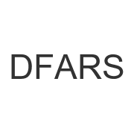
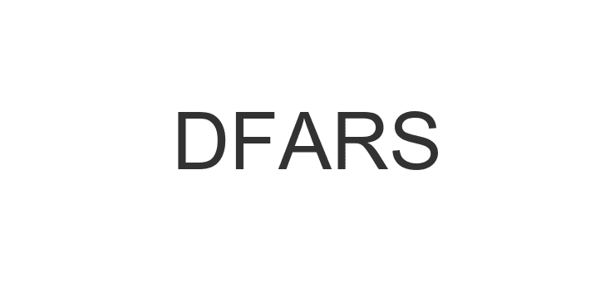
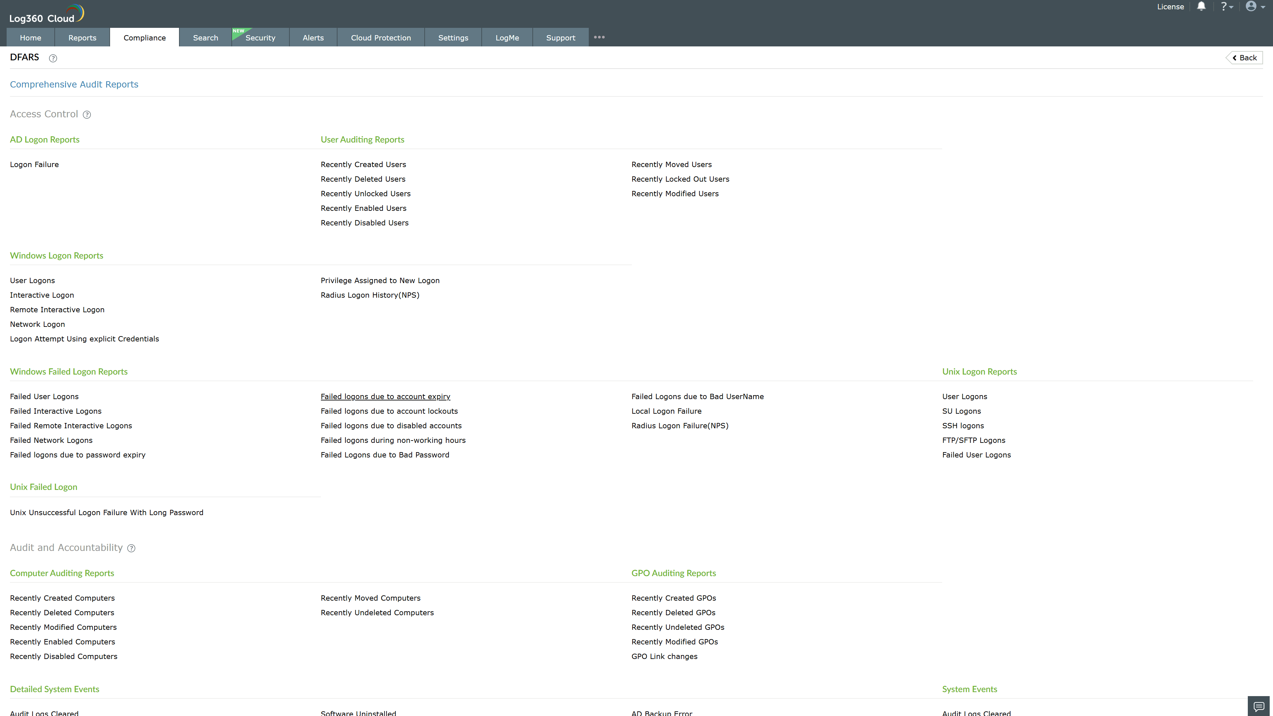
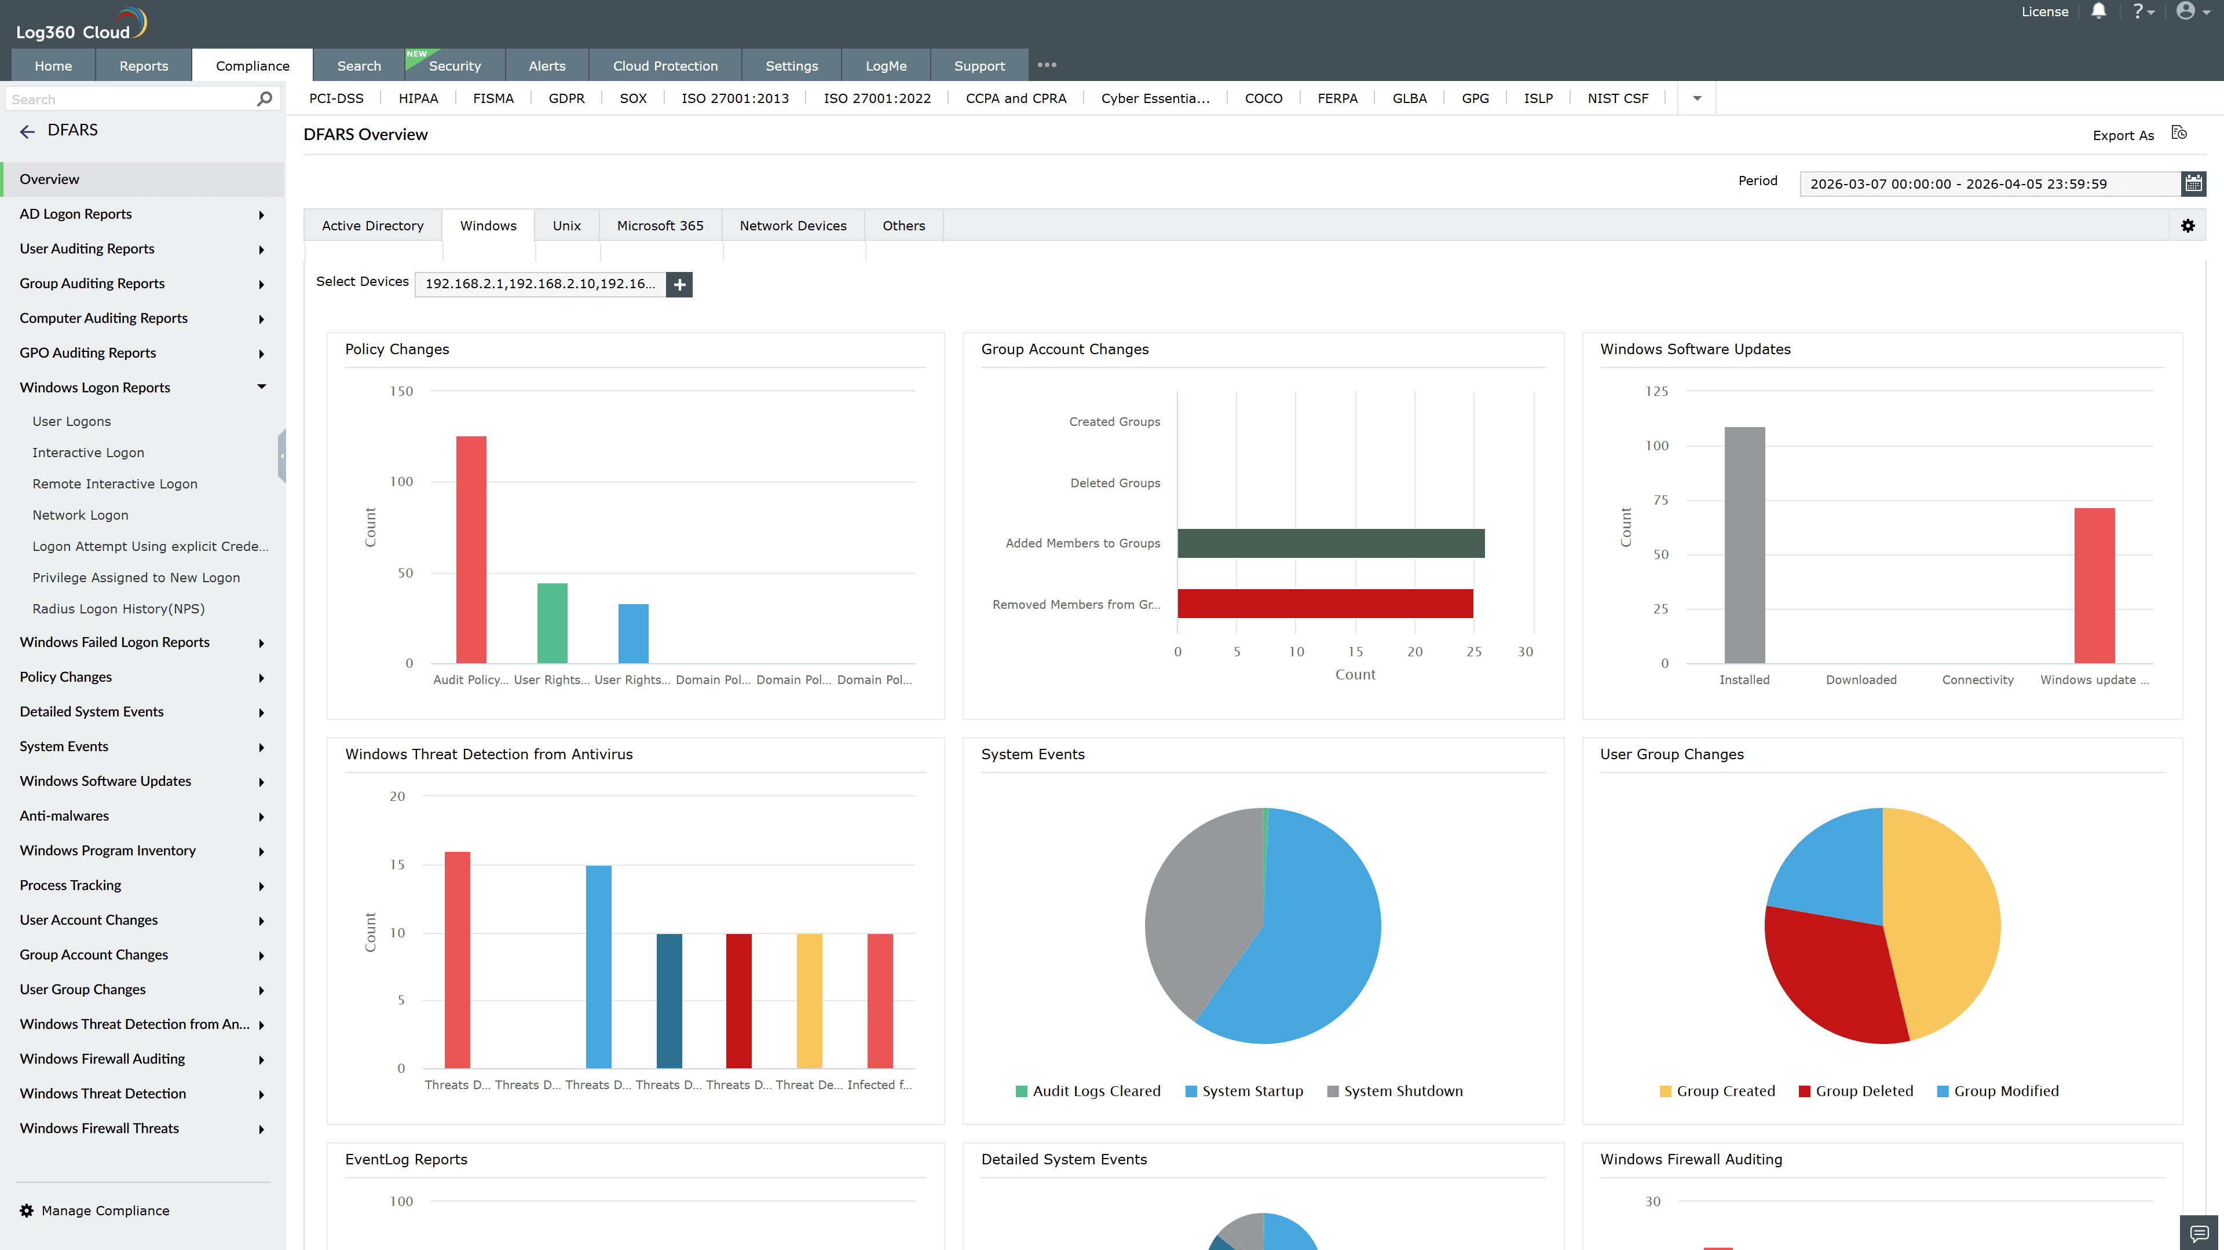
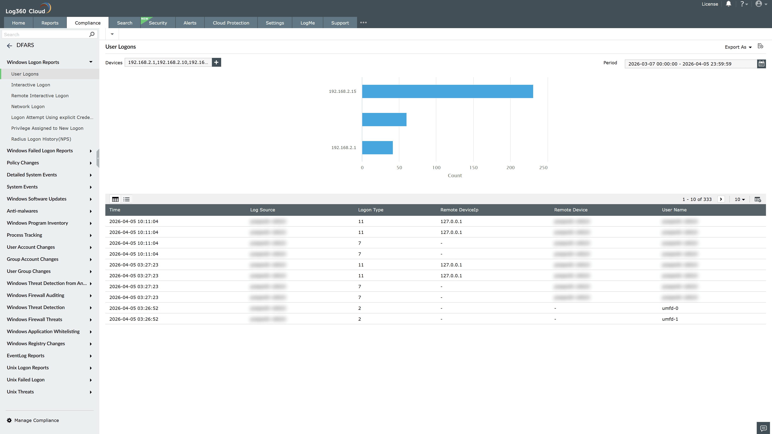
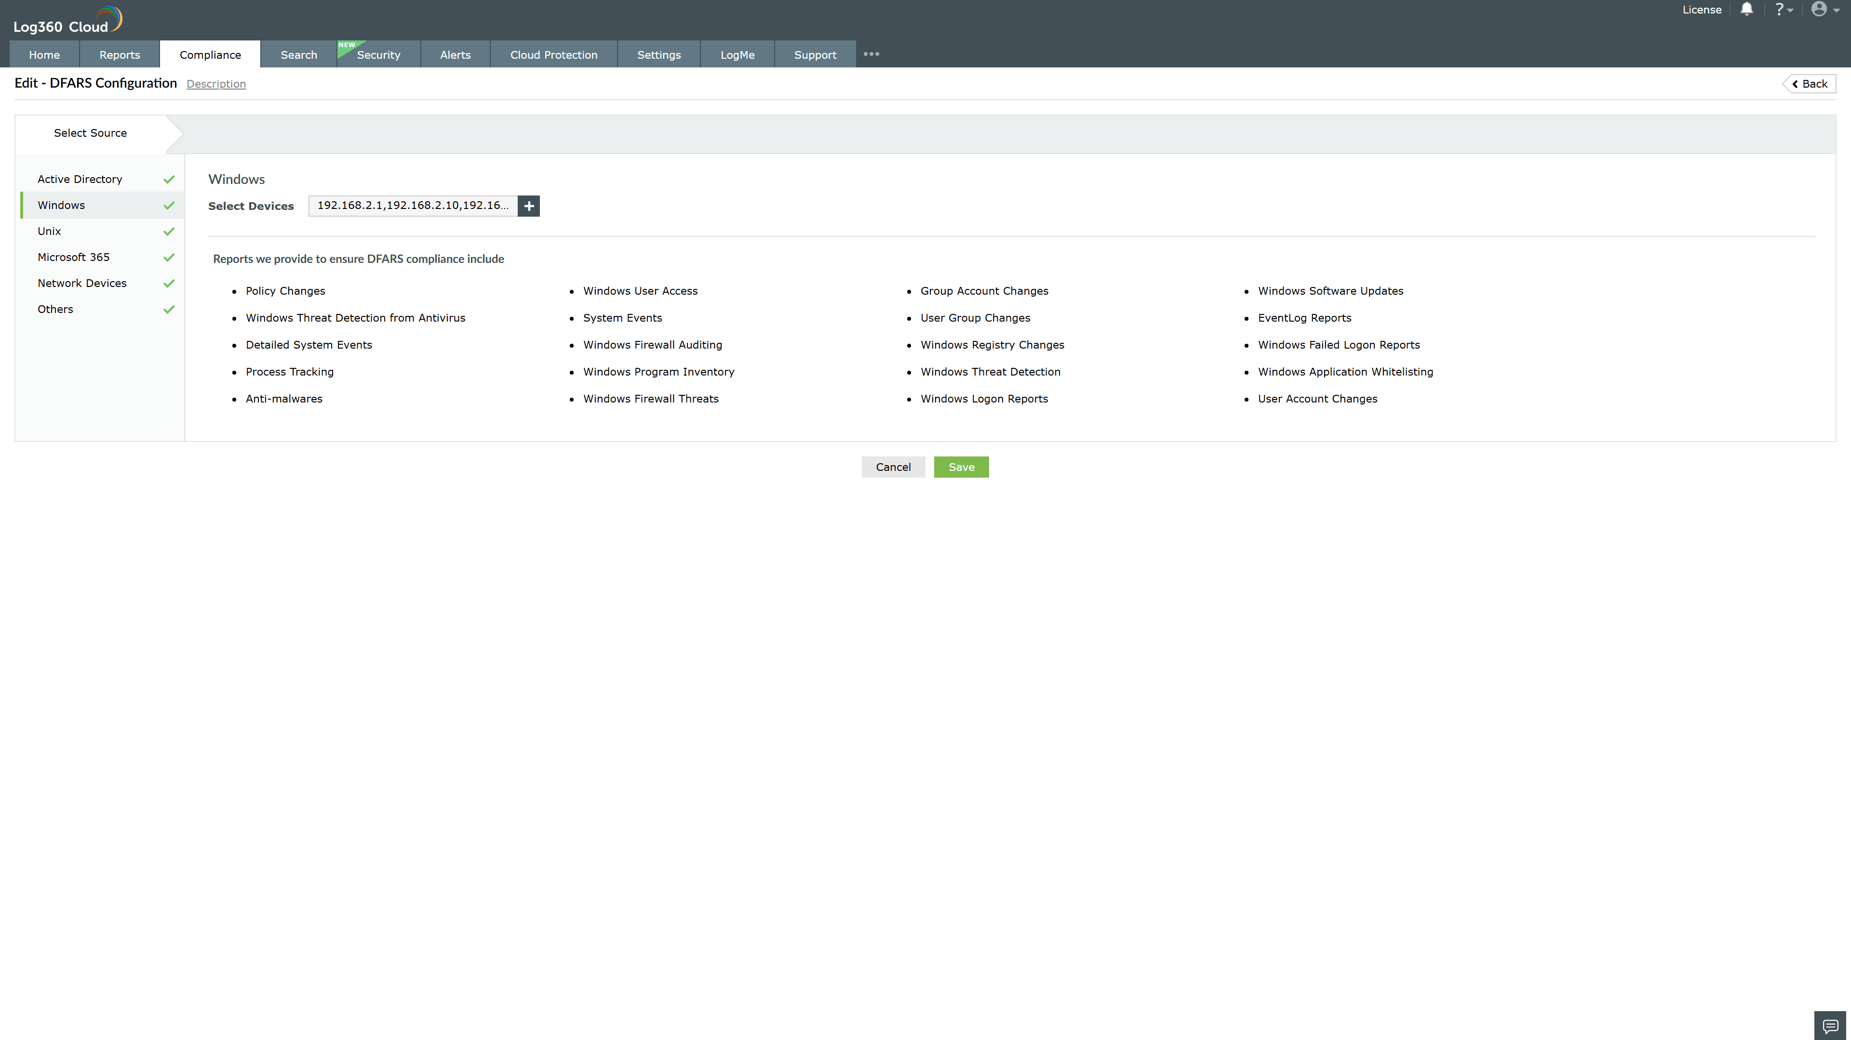
Valid Submission : Yes
Supported Editions : Free, Basic, Standard, Professional, MSSP
Help Document : https://www.manageengine.com/log-management/help/integrations/compliance-extensions.html
Help Video : Not provided
Tags : Log360, Compliance, Privacy monitoring, Data privacy, Regulatory compliance
Supported DCs : US, IN, JP, CA, AU, UK and EU
Privacy Policy:
Terms of Service:
Release Notes:
Predefined reports for the DFARS.

